Session 1

Assignment 1 Question

*Session 1: Assignment 1*

**Table of Contents**

1. Introduction

2. Problem Statement

3. Output

**1. Introduction**

This assignment will help you to consolidate the concepts learnt in the session.

**2. Problem Statement**

**Task 1:**

1.

Install Jupyter notebook and run the first program and share the screenshot of the output.

LINK

2.

Write a program which will find all such numbers which are divisible by 7 but are not a multiple

of 5, between 2000 and 3200 (both included). The numbers obtained should be printed in a

comma-separated sequence on a single line.

3.

Write a Python program to accept the user's first and last name and then getting them printed in

the the reverse order with a space between first name and last name.

4.

Write a Python program to find the volume of a sphere with diameter 12 cm.

Formula: V=4/3 * π * r 3

**Task 2:**

1.

Write a program which accepts a sequence of comma-separated numbers from console and

generate a list.

2.

Create the below pattern using nested for loop in Python.

*

* *

* * *

* * * *

* * * * *

* * * *

* * *

* *

*

3.

Write a Python program to reverse a word after accepting the input from the user.

**Sample Output:**

Input word: AcadGild

Output: dilGdacA

4.

Write a Python Program to print the given string in the format specified in the **sample output.**

WE, THE PEOPLE OF INDIA, having solemnly resolved to constitute India into a

SOVEREIGN, SOCIALIST, SECULAR, DEMOCRATIC REPUBLIC and to secure to all

its citizens

**Sample Output:**

WE, THE PEOPLE OF INDIA,

having solemnly resolved to constitute India into a SOVEREIGN, !

SOCIALIST, SECULAR, DEMOCRATIC REPUBLIC

and to secure to all its citizens

**NOTE: The solution shared through Github should contain the source code used and**

**the screenshot of the output.**

**3. Output**

**Task 1:**

1.

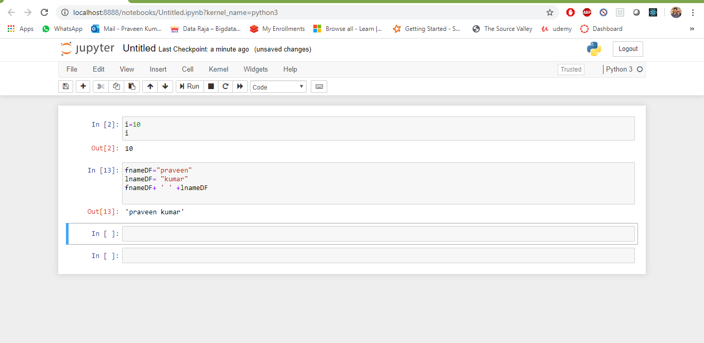

2.

newLine=[]

for x in range(2000, 3201):

if (x%7==0) and (x%5!=0):

newLine.append(str(x))

print (','.join(newLine))

Output-



3.

fname="praveen"

lname ="kumar"

fullname = fname + ' ' + lname

print(fullname)

reversename = fullname[::-1]

print(reversename)

Input-praveen kumar

Output - **ramuk neevarp**

4.

Write a Python program to find the volume of a sphere with diameter 12 cm.

Formula: V=4/3 * π * r 3

Pi=3.14

diameter =12

radius = diameter/2

Volume=4/3*Pi*radius*radius*radius

print(Volume)

Output - **904.3199999999998**

**Task 2:**

1.

inputnumber = input()

list = inputnumber.split(",")

print(list)

Input- 1,8,7,6

Output- **['1', '8', '7', '6']**

2.

n=5

for i in range(1,n+1):

 print('* '*i)

for m in range(1,n):

 print('* '*(n-m))

Input- 5

Output-

*

* *

* * *

* * * *

* * * * *

* * * *

* * *

* *

*

3.

inputword = input()

reverseword = inputword[::-1]

print(reverseword)

Input- praveen

Output- **neevarp**

4.

input = """WE, THE PEOPLE OF INDIA, \n having solemnly resolved to constitute India into a SOVEREIGN, \n SOCIALIST, SECULAR, DEMOCRATIC REPUBLIC \n and to secure to all its citizens"""

print(input)

Output-

